**Nama : Dinny Fauziatunnisa Iskandar**

**NIM : 12200592**

**Kelas : 12.3B.13**

**WEB PROGRAMMING II**

**PERTEMUAN 6**

1. **Tampilan Database “Pustaka”**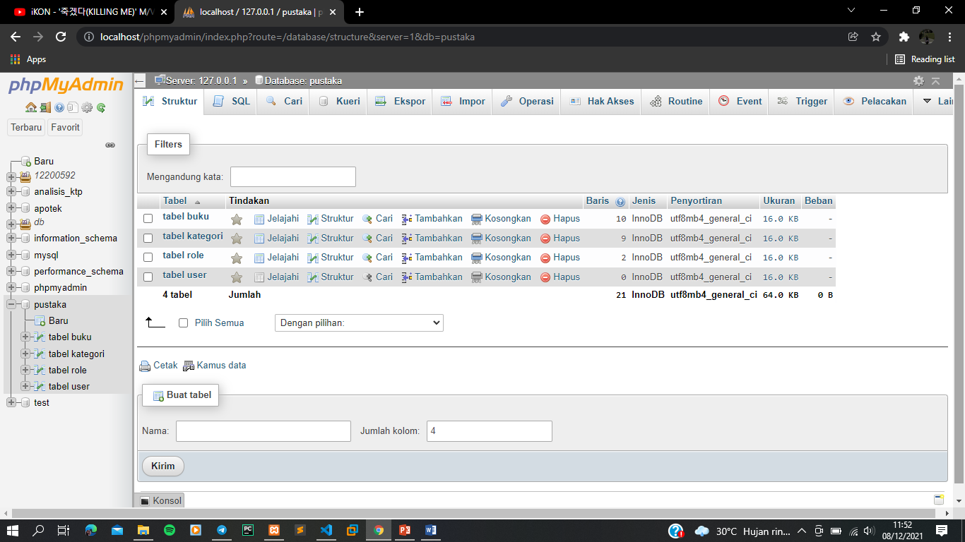
2. **Isi Tabel Buku** 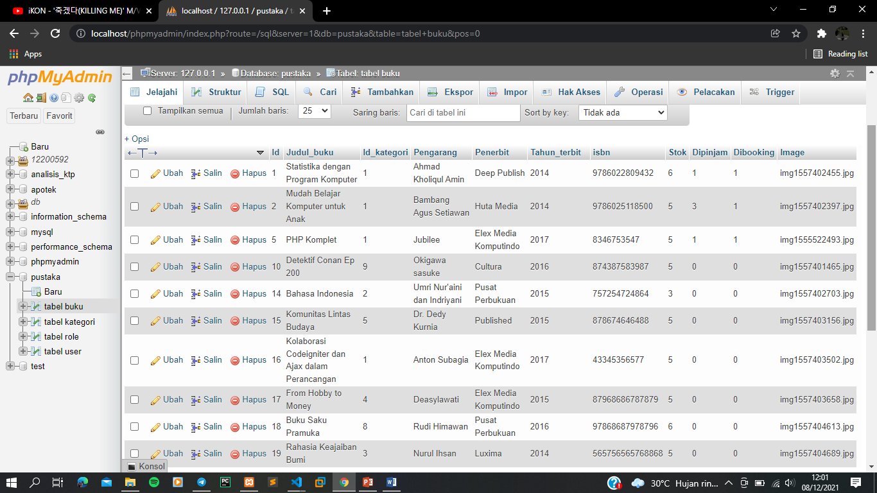
3. **Isi Tabel Kategori**

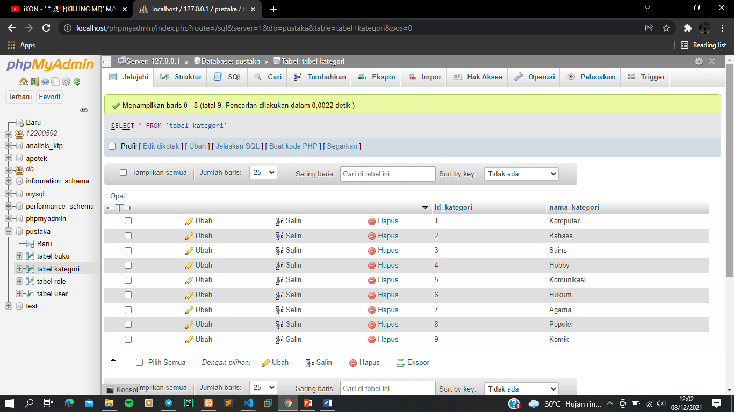

1. **Isi Tabel Role** 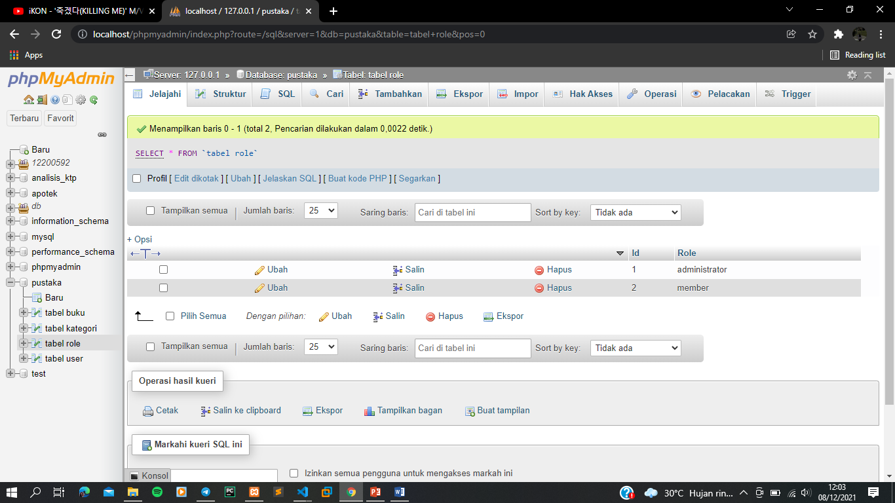
2. **Script coding “Database.php”**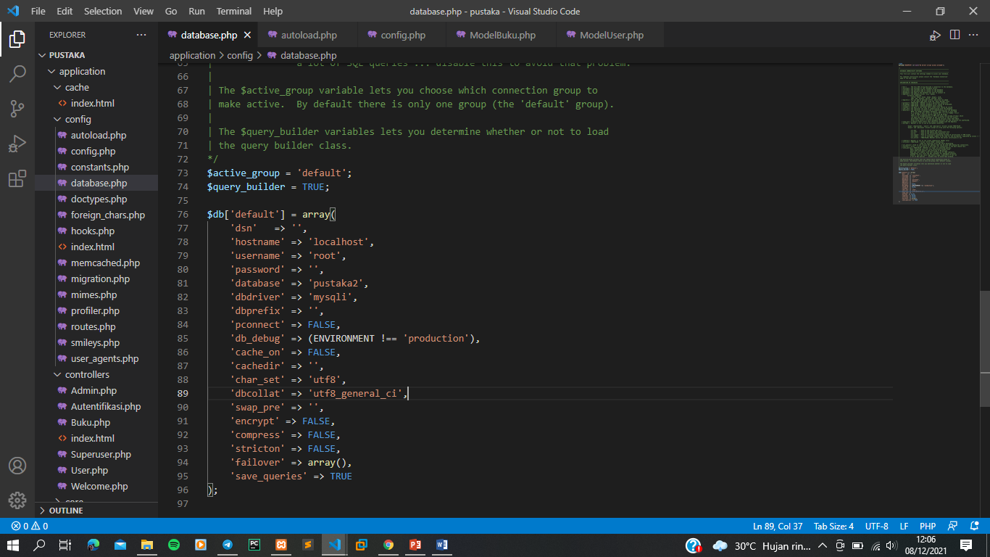
3. **Script coding “Autoload.php”**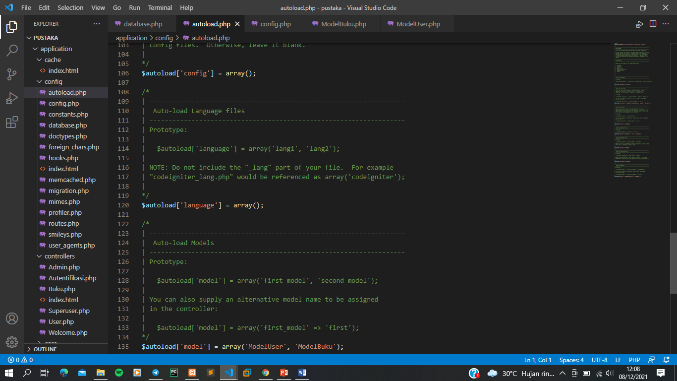

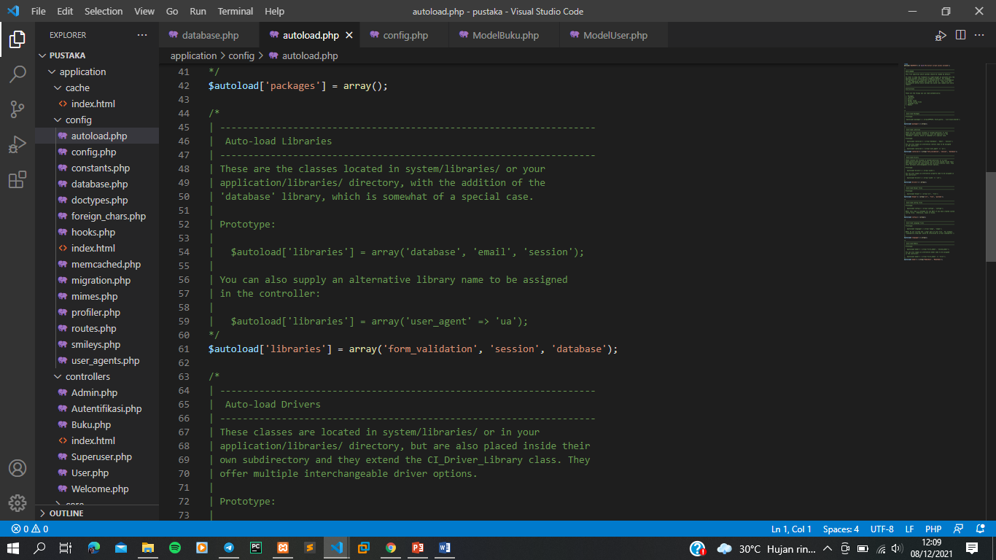

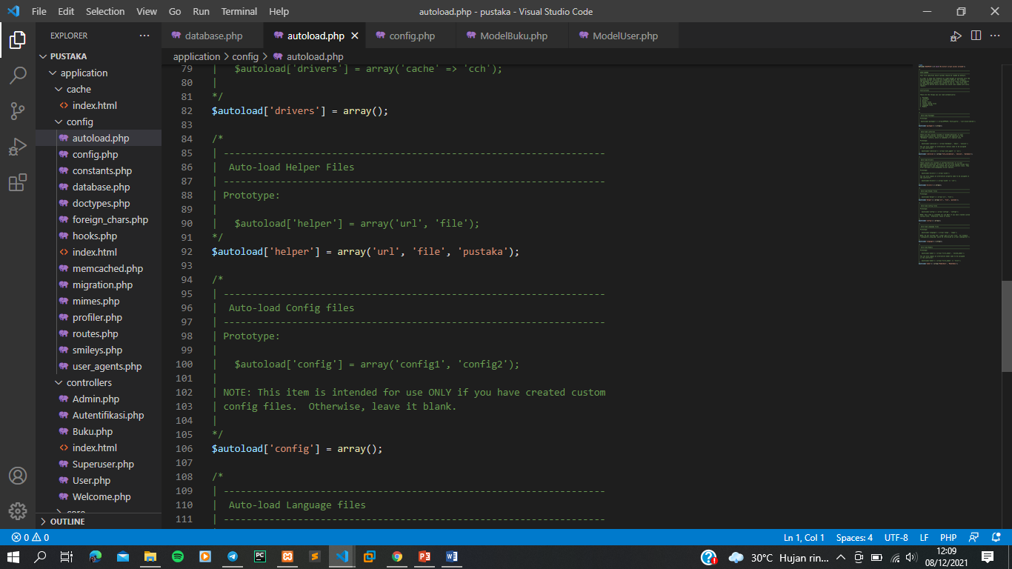

1. **Script coding “config.php”**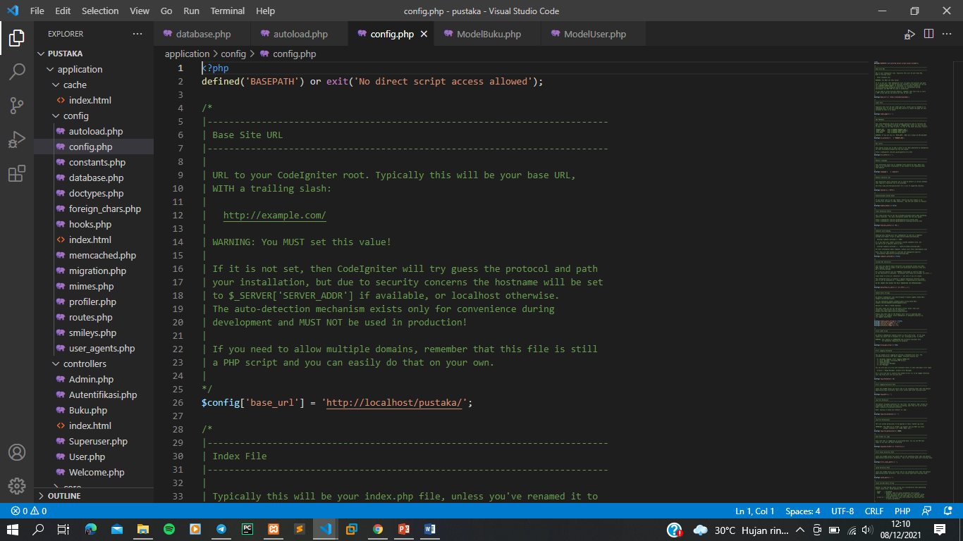
2. **Script coding “ModelBuku.php”**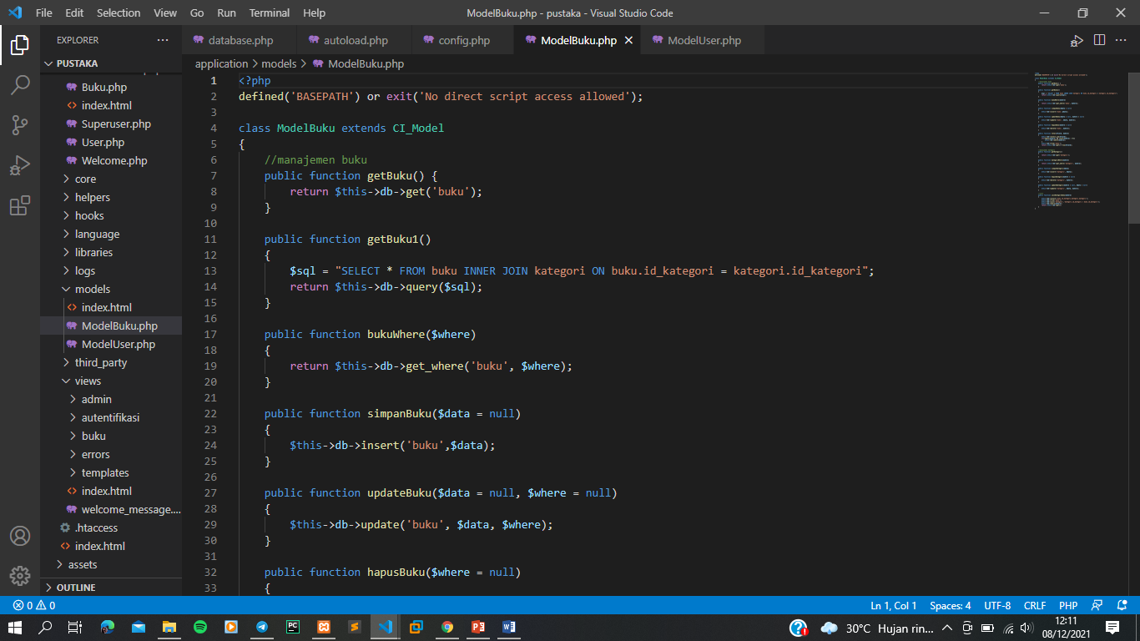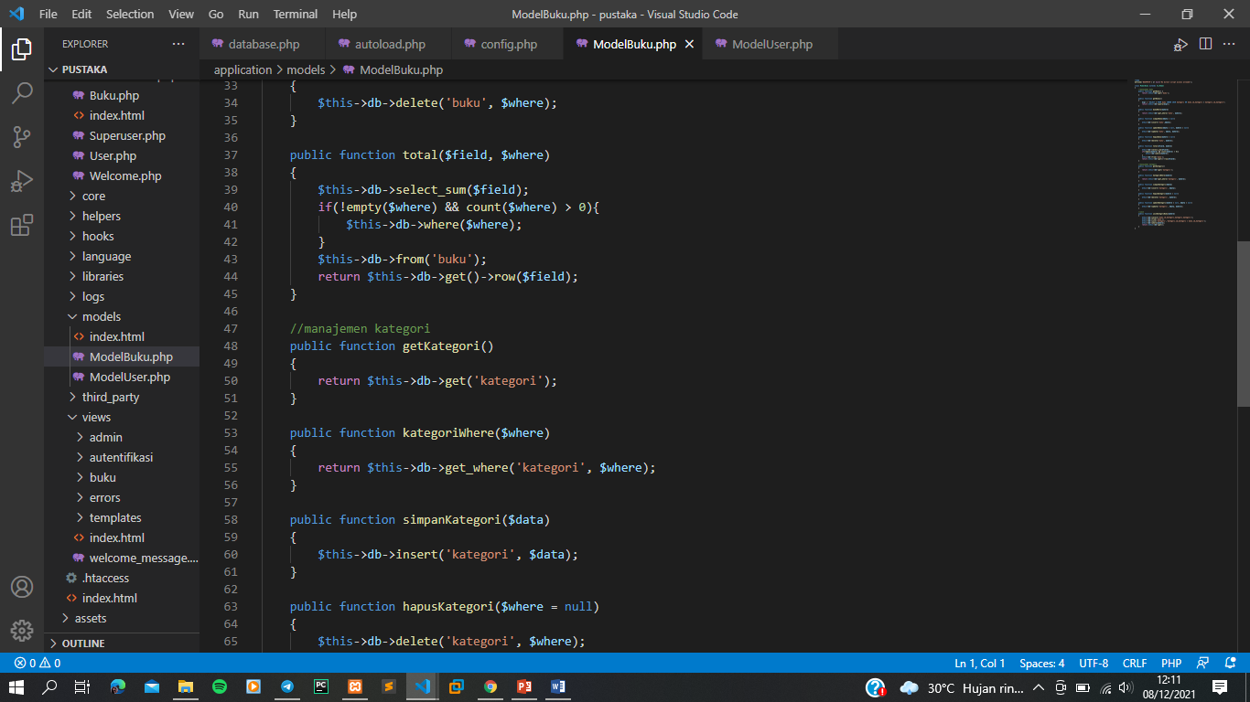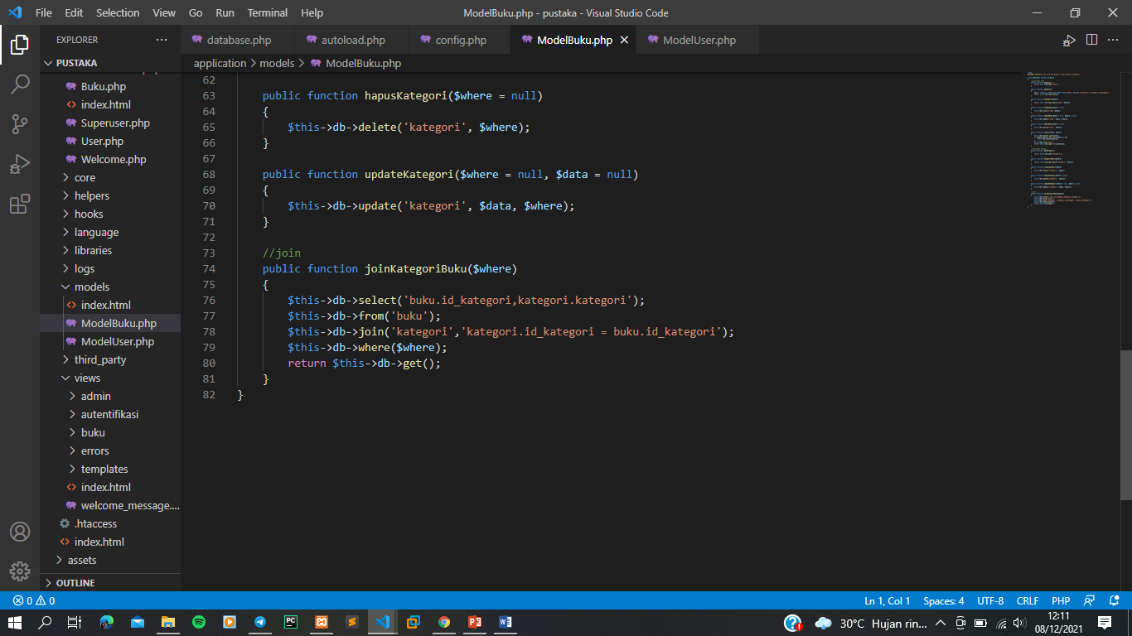
3. **Script coding “ModelUser.php”**